# **LAMPIRAN**

Curriculum Vitae:

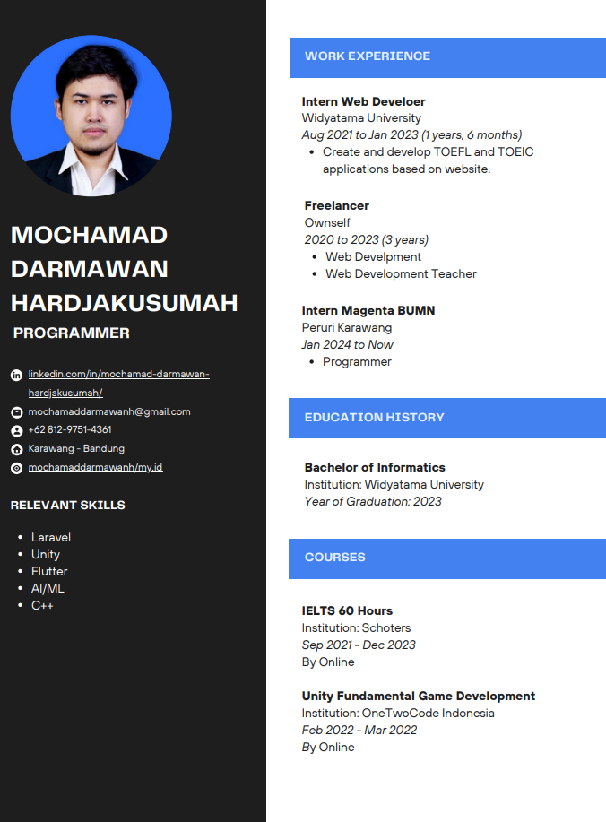

Scan Revisi Sidang:

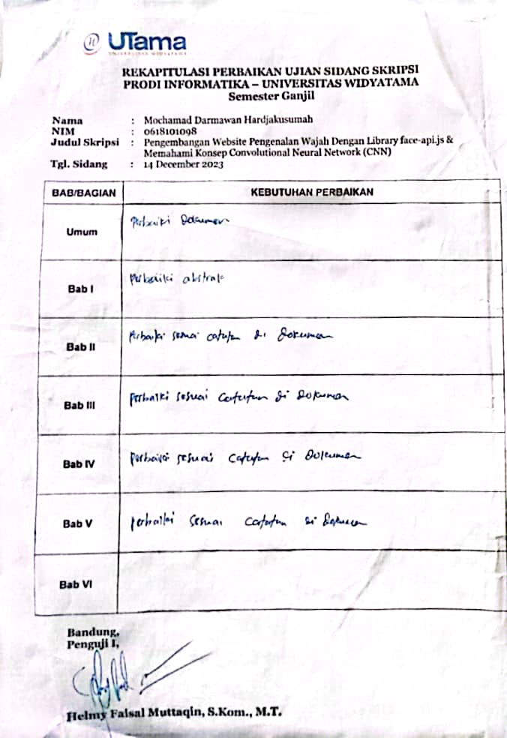

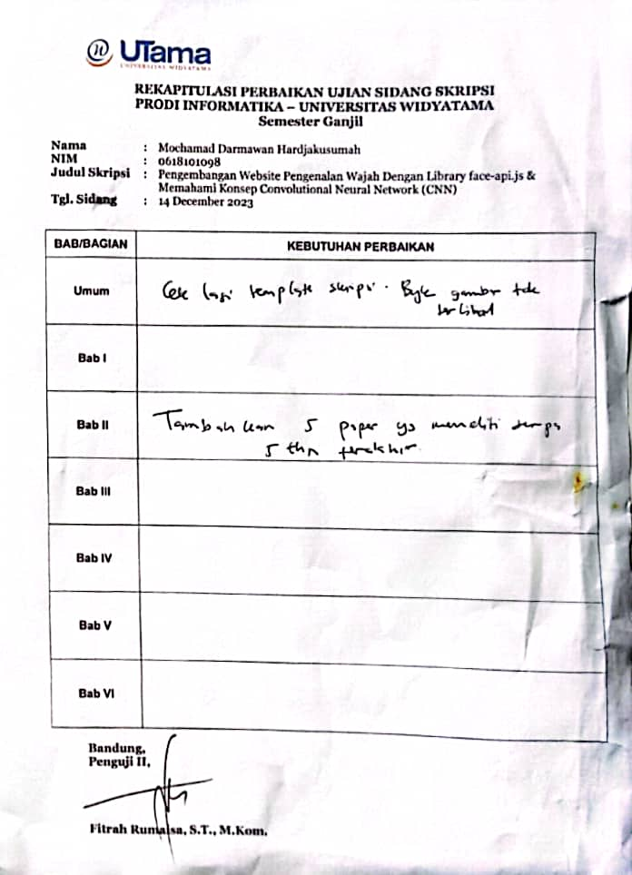

Scan Kartu Bimbingan:

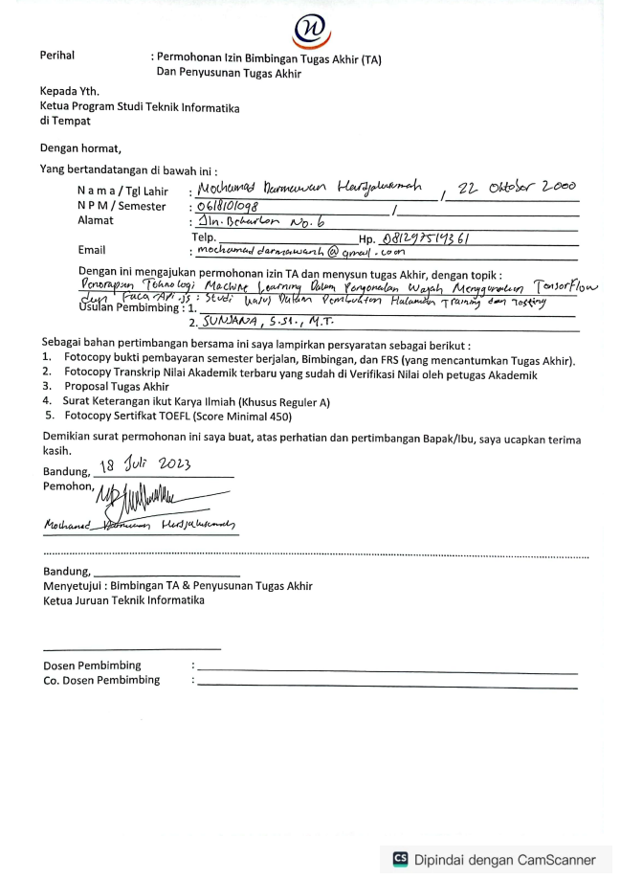

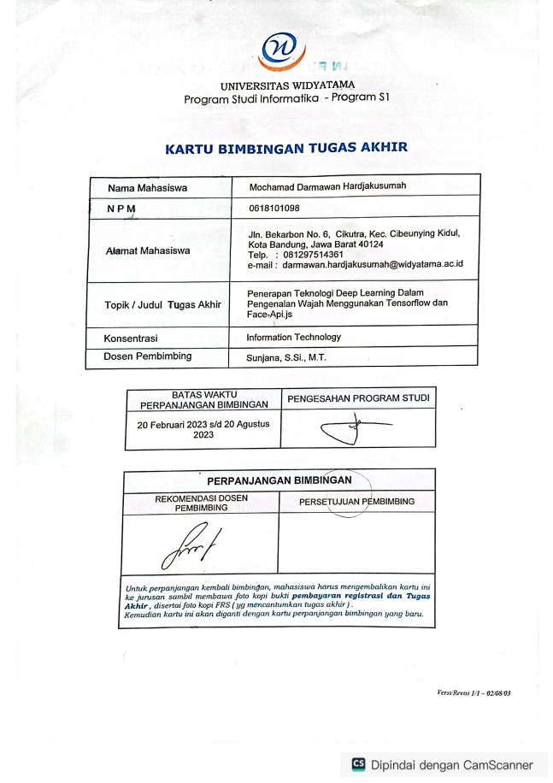

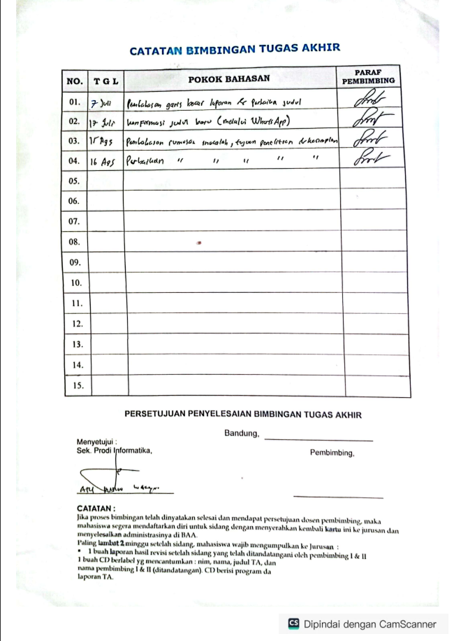

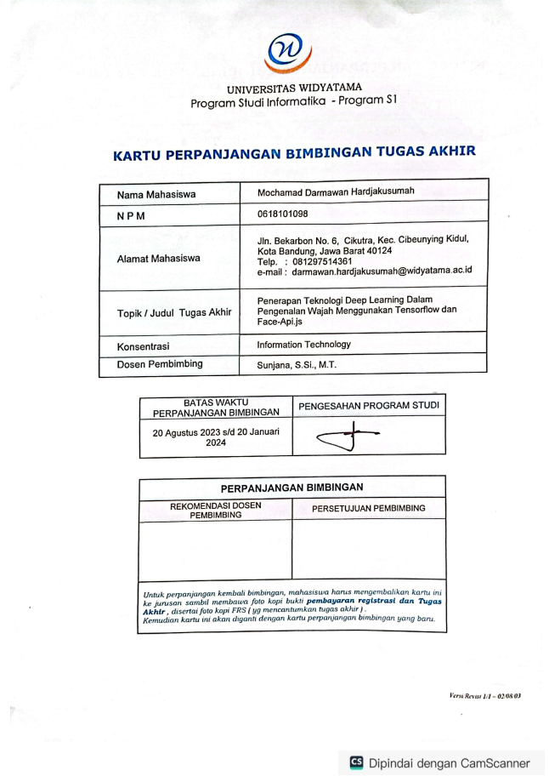

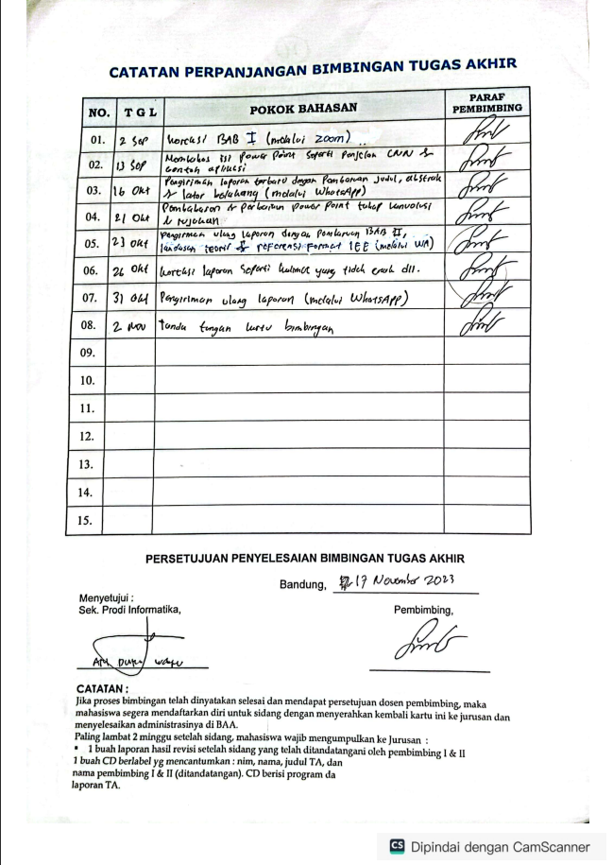

Verifikasi Abstrak:

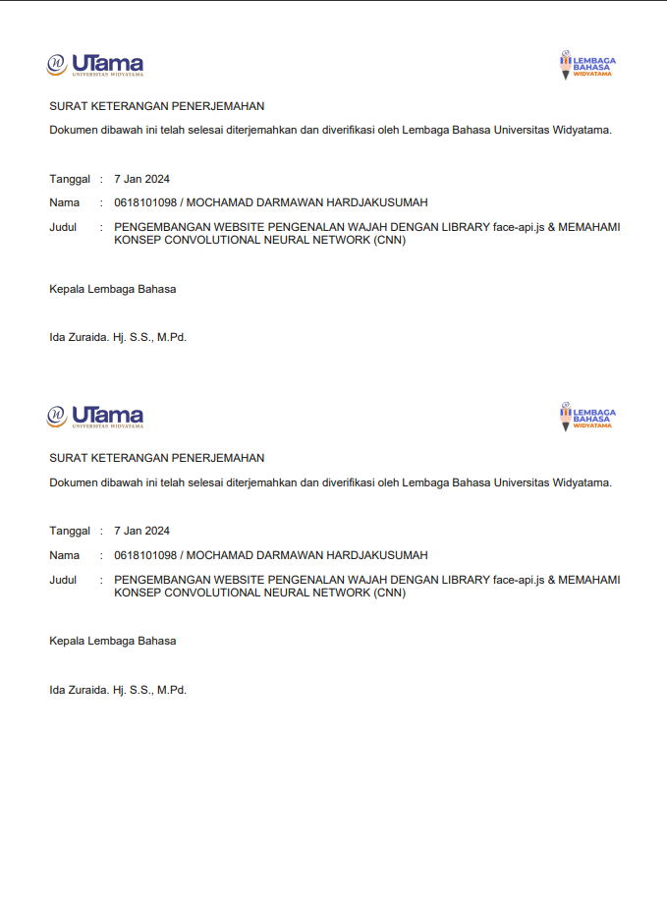

Source Code:

<https://github.com/mochamaddarmawanh/skripsi>

[https://github.com/mochamaddarmawanh/f](https://github.com/mochamaddarmawanh/skripsi)ace_recognition

[https://m](https://github.com/mochamaddarmawanh/skripsi)ochamaddarmawanh.000webhostapp.com/face_recognition